Camera Shot Types
There is a convention in the video, film and television industries which assigns names and guidelines to common types of shots, framing and picture composition. The list below briefly describes the most common shot types. Note that the exact terminology may vary between production environments but the basic principles are the same.
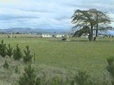  EWS (Extreme Wide Shot)  The view is so far from the subject that she isn't even visible. This is often used as an establishing shot. | 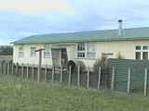  VWS (Very Wide Shot) (also called  an Establishment Shot)  The subject is visible (barely), but the emphasis is still on placing her in her environment. | 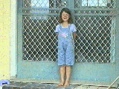  WS (Wide Shot)  The subject takes up the full frame, or at least as much as possible. The same as a long shot.
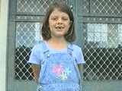  MS (Mid Shot)  Shows some part of the subject in more detail while still giving an impression of the whole subject. | 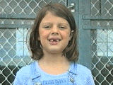  MCU (Medium Close Up)  Half way between a MS and a CU. | 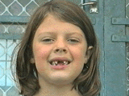  CU (Close Up)  A certain feature or part of the subject takes up the whole frame.
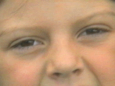  ECU (Extreme Close Up)  The ECU gets right in and shows extreme detail. | (OSS) Over-the-Shoulder Shot  Looking from behind a person at the subject. | Noddy Shot  Usually refers to a shot of the interviewer listening and reacting to the subject; can be used in drama and other situations.
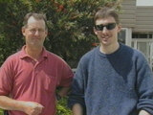  Two-Shot  A comfortable shot of two people, framed similarly to a mid shot. | 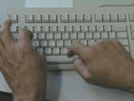  Point-of-View Shot (POV)  Shows a view from the subject's perspective. | 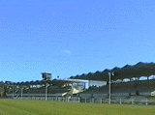  Weather Shot  The subject is the weather, usually the sky. Can be used for other purposes.
Worm’s Eye View  Shows a scene from the ground looking up, another unnatural and strange angle. | Birds Eye View  Shows a scene from directly overhead, looking down on the action. Makes people look insignificant, ant-like. | 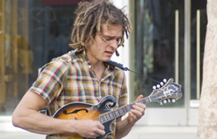  Eye Level Shot  A fairly neutral shot; camera is positioned as though a human is observing the scene.

Low Angle Shot
Gives a sense of speeded motion, gives a sense of confusion to the viewer or powerlessness.
Background is usually sky or ceiling.

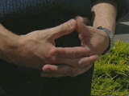
Dolly
A shot where the camera moves closer to the subject, or backs up from the subject.

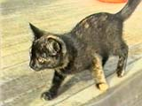
Truck
A shot where the camera moves along with the subject, side to side. (move your feet for this shot)

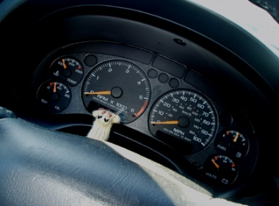

Oblique/Canted Angle shot
Camera is tilted to suggest imbalance, transition, or instability. (very popular in horror movies). Can be used to suggest ‘point of view’ from a character’s eyes.

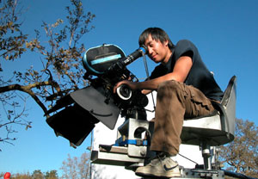 High Angle shot
Camera is elevated above the action, using a crane to give a general overview. Makes object photographed seem smaller, less significant

Pan Shot
A shot where the camera moves on its axis from left to right or right to left—usually a scenery shot. (camera stays still but moves side to side)

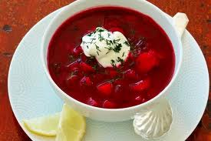
Tilt
A shot where the camera tilts up or down on its tripod, but doesn’t move its wheels at all.

Up next: find each type of shot in a magazine article. Cut out and label each one as you glue it to a sheet of paper. There are 20 different shots to find. Work with a partner or alone.

To put your collage of shots together:

- Select pictures from magazines illustrating that particular shot technique. Be sure they will fit on ½ of a sheet of paper—choose smaller shots whenever possible.

- At the top of the sheet, write the name of the shot. Write neatly!

- Glue the magazine picture to the sheet.

- Add a cover with your name and a picture that you like.

- Staple the sheets together to form a booklet.

